Experiment No. 3
Student Name: Ojaswini Thote
PRN: 24070521048
File Path: file:///Users/ojaswinithote/Desktop/Javascript/EXP%203/index.html | file:///Users/ojaswinithote/Desktop/Javascript/EXP%203/index1.html | file:///Users/ojaswinithote/Desktop/Javascript/EXP%203/index.html2

Experiment Title
Implementation of Control Structures and Form Validation; Development of a Student Grading System and Password Validation Web Application using JavaScript

Software / Tools Required
- Visual Studio Code
- Google Chrome
- HTML5
- CSS3
- JavaScript (ES6)

Experiment Program Code

Task 1 — Student Grading System (`index.html` + `script.js`)

`Task 1/index.html`
<!DOCTYPE html>
<html lang="en">
<head>
<meta charset="UTF-8">
<meta name="viewport" content="width=device-width, initial-scale=1.0">
<title>Student Grading System</title>
<style>
*{
margin:0;
padding:0;
box-sizing:border-box;
font-family: "Segoe UI", sans-serif;
}
body{
min-height:100vh;
display:flex;
justify-content:center;
align-items:center;
background:linear-gradient(135deg, #F5F1EA, #E8E2D8);
}
.container{
width:450px;
background:#fff;
padding:35px;
border-radius:20px;
box-shadow:0 10px 25px rgba(0,0,0,0.1);
border:1px solid #D6CEC2;
}
h2{
text-align:center;
color:#5C5248;
margin-bottom:25px;
}
label{
display:block;
margin-bottom:8px;
font-weight:600;
color:#6B6258;
}
input[type="text"],
input[type="number"]{
width:100%;
padding:12px;
margin-bottom:18px;
border:1px solid #D8D2C8;
border-radius:10px;
background:#FAF8F5;
font-size:15px;
}
input:focus{
outline:none;
border-color:#A99985;
}
.radio-group{
display:flex;
gap:15px;
margin-bottom:20px;
flex-wrap:wrap;
}
.radio-group label{
font-weight:normal;
color:#4A423A;
}
input[type="button"]{
width:100%;
padding:13px;
border:none;
border-radius:10px;
background:#8B7D6B;
color:white;
font-size:16px;
cursor:pointer;
transition:0.3s;
}
input[type="button"]:hover{
background:#746658;
}
.result-box{
margin-top:25px;
background:#F7F4EF;
padding:15px;
border-radius:10px;
border-left:5px solid #8B7D6B;
}
.result-box h3{
color:#5C5248;
margin-bottom:10px;
}
#result{
line-height:1.8;
color:#4A423A;
}
</style>
</head>
<body>
<div class="container">
<h2>🎓 Student Grading System</h2>
<label>Student Name</label>
<input type="text" id="name" placeholder="Enter your name">
<label>Roll Number</label>
<input type="text" id="roll" placeholder="Enter roll number">
<label>Subject Name</label>
<input type="text" id="subject" placeholder="Enter subject name">
<label>Semester</label>
<div class="radio-group">
<label>
<input type="radio" name="semester" value="Semester 1">
Semester 1
</label>
<label>
<input type="radio" name="semester" value="Semester 2">
Semester 2
</label>
<label>
<input type="radio" name="semester" value="Semester 3">
Semester 3
</label>
<label>
<input type="radio" name="semester" value="Semester 4">
Semester 4
</label>
<label>
<input type="radio" name="semester" value="Semester 5">
Semester 5
</label>
<label>
<input type="radio" name="semester" value="Semester 6">
Semester 6
</label>
</div>
<label>Marks</label>
<input type="number" id="marks" placeholder="Enter marks (0-100)">
<input type="button"
value="Calculate Grade"
onclick="gradeSystem()">
<div class="result-box">
<h3>Result</h3>
<p id="result">Student details will appear here.</p>
</div>
</div>
<script src="script.js"></script>
</body>
</html>

`Task 1/script.js`
function gradeSystem() {
var name = document.getElementById("name").value;
var roll = document.getElementById("roll").value;
var subject = document.getElementById("subject").value;
var marks = parseInt(document.getElementById("marks").value);
var semester = document.querySelector(
'input[name="semester"]:checked'
);
// Validation
if (name == "") {
alert("Please enter the student name!");
return;
}
if (roll == "") {
alert("Please enter the roll number!");
return;
}
if (subject == "") {
alert("Please enter the subject name!");
return;
}
if (semester == null) {
alert("Please select a semester!");
return;
}
if (isNaN(marks)) {
alert("Please enter the marks!");
return;
}
if (marks < 0 || marks > 100) {
alert("Marks should be between 0 and 100!");
return;
}
// Grade Calculation
var grade;
if (marks >= 50 && marks <= 65) {
grade = "C";
}
else if (marks >= 66 && marks <= 80) {
grade = "B";
}
else if (marks > 80 && marks <= 90) {
grade = "A";
}
else if (marks > 90) {
grade = "A+";
}
else {
grade = "Fail";
}
// Display Result
document.getElementById("result").innerHTML =
"<strong>Student Name:</strong> " + name +
"<br><strong>Roll Number:</strong> " + roll +
"<br><strong>Subject Name:</strong> " + subject +
"<br><strong>Semester:</strong> " + semester.value +
"<br><strong>Marks:</strong> " + marks +
"<br><strong>Grade:</strong> " + grade;
// Success Message
alert("Result generated successfully!");
}
This application accepts student academic details and calculates the final grade based on the marks entered by the user.
Features:
- Student Name
- Roll Number
- Subject Name
- Semester Selection
- Marks Entry
- Grade Calculation
- Pass/Fail Result
- Input Validation using Control Structures
The application uses JavaScript if-else-if statements to assign grades and validate the entered marks before displaying the result.

Task 2 — Password Validation System (`index1.html` + `script1.js`)

`Task 2/index1.html`
<!DOCTYPE html>
<html lang="en">
<head>
<meta charset="UTF-8">
<meta name="viewport" content="width=device-width, initial-scale=1.0">
<title>User Login Portal</title>
<style>
*{
margin:0;
padding:0;
box-sizing:border-box;
font-family:"Segoe UI",sans-serif;
}
body{
min-height:100vh;
display:flex;
justify-content:center;
align-items:center;
background:linear-gradient(135deg,#F5F1EA,#E8E2D8);
padding:20px;
}
.box{
width:500px;
max-width:90%;
background:#FFFFFF;
padding:35px;
border-radius:20px;
border:1px solid #D6CEC2;
box-shadow:0 10px 25px rgba(0,0,0,0.1);
}
h1{
text-align:center;
color:#5C5248;
margin-bottom:5px;
}
h2{
text-align:center;
color:#8B7D6B;
margin-bottom:25px;
font-size:18px;
font-weight:400;
}
label{
display:block;
margin-bottom:8px;
color:#6B6258;
font-weight:600;
}
input[type="text"],
input[type="password"],
input[type="number"]{
width:100%;
padding:12px;
margin-bottom:15px;
border:1px solid #D8D2C8;
border-radius:10px;
background:#FAF8F5;
font-size:15px;
}
input:focus{
outline:none;
border-color:#A99985;
}
.radio-group{
display:flex;
gap:20px;
margin-bottom:20px;
flex-wrap:wrap;
}
.requirements{
background:#F7F4EF;
padding:15px;
border-radius:10px;
border-left:5px solid #8B7D6B;
margin-bottom:20px;
color:#4A423A;
}
.requirements ul{
margin-left:20px;
margin-top:8px;
}
.requirements li{
margin-bottom:4px;
}
button{
width:100%;
padding:13px;
border:none;
border-radius:10px;
background:#8B7D6B;
color:white;
font-size:16px;
cursor:pointer;
transition:0.3s;
}
button:hover{
background:#746658;
}
#output{
margin-top:20px;
padding:15px;
border-radius:10px;
background:#F7F4EF;
border-left:5px solid #8B7D6B;
color:#4A423A;
}
</style>
</head>
<body>
<div class="box">
<h1>🔐 User Login Portal</h1>
<h2>Student Registration Form</h2>
<label>Full Name</label>
<input type="text"
id="name"
placeholder="Enter your full name">
<label>Email Address</label>
<input type="text"
id="email"
placeholder="Enter your email">
<label>Phone Number</label>
<input type="number"
id="phone"
placeholder="Enter 10-digit phone number">
<label>City</label>
<input type="text"
id="city"
placeholder="Enter your city">
<label>Gender</label>
<div class="radio-group">
<label>
<input type="radio"
name="gender"
value="Male">
Male
</label>
<label>
<input type="radio"
name="gender"
value="Female">
Female
</label>
<label>
<input type="radio"
name="gender"
value="Other">
Other
</label>
</div>
<label>Role</label>
<div class="radio-group">
<label>
<input type="radio"
name="role"
value="Student"
checked>
Student
</label>
<label>
<input type="radio"
name="role"
value="Faculty">
Faculty
</label>
<label>
<input type="radio"
name="role"
value="Admin">
Admin
</label>
</div>
<label>Password</label>
<input type="password"
id="password"
placeholder="Enter Password">
<div class="requirements">
<strong>Password Requirements:</strong>
<ul>
<li>Minimum 8 characters</li>
<li>At least 1 uppercase letter</li>
<li>At least 1 lowercase letter</li>
<li>At least 1 number</li>
<li>At least 1 special character</li>
</ul>
</div>
<label>Confirm Password</label>
<input type="password"
id="confirmPassword"
placeholder="Confirm Password">
<button onclick="login()">
Login
</button>
<div id="output">
Login status will appear here.
</div>
</div>
<script src="script1.js"></script>
</body>
</html>

`Task 2/script1.js`
function login() {
let name = document.getElementById("name").value.trim();
let email = document.getElementById("email").value.trim();
let phone = document.getElementById("phone").value.trim();
let city = document.getElementById("city").value.trim();
let password = document.getElementById("password").value;
let confirmPassword = document.getElementById("confirmPassword").value;
let gender = document.querySelector(
'input[name="gender"]:checked'
);
// Name Validation
if (!/^[A-Za-z ]+$/.test(name)) {
alert(
"Name should contain only alphabets and spaces."
);
return;
}
// Email Validation
let emailPattern =
/^[^\s@]+@[^\s@]+\.[^\s@]+$/;
if (!emailPattern.test(email)) {
alert("Please enter a valid email address.");
return;
}
// Phone Validation
let phonePattern = /^\d{10}$/;
if (!phonePattern.test(phone)) {
alert(
"Phone number must contain exactly 10 digits."
);
return;
}
// City Validation
if (city === "") {
alert("Please enter your city.");
return;
}
// Gender Validation
if (!gender) {
alert("Please select your gender.");
return;
}
// Password Validation
// Minimum 8 characters
// One uppercase letter
// One lowercase letter
// One number
// One special character
let passwordPattern =
/^(?=.*[a-z])(?=.*[A-Z])(?=.*\d)(?=.*[@$!%*?&]).{8,}$/;
if (!passwordPattern.test(password)) {
alert(
"Password must contain:\n\n" +
"• Minimum 8 characters\n" +
"• One uppercase letter\n" +
"• One lowercase letter\n" +
"• One number\n" +
"• One special character"
);
return;
}
// Confirm Password Validation
if (password !== confirmPassword) {
alert("Passwords do not match.");
return;
}
// Success Message
document.getElementById("output").innerHTML = `
<strong>Login Successful!</strong><br>
Welcome, ${name}!<br>
Redirecting to Student Grading System...
`;
// Redirect after 1.5 seconds
setTimeout(function () {
window.location.href = "index2.html";
}, 1500);
}
This webpage demonstrates form validation by allowing users to register through a login portal.
Features:
- Full Name
- Email Address
- Phone Number
- City
- Gender Selection
- User Role Selection
- Password & Confirm Password
- Password Strength Validation
- Login Status Display
The password validation checks for:
- Minimum 8 characters
- Uppercase letter
- Lowercase letter
- Numeric digit
- Special character
- Password confirmation

Task 3 — Student Grading Portal (`index2.html` + `script2.js`)

`Task 3/index2.html`
<!DOCTYPE html>
<html lang="en">
<head>
<meta charset="UTF-8">
<meta name="viewport" content="width=device-width, initial-scale=1.0">
<title>Student Grading Portal</title>
<style>
*{
margin:0;
padding:0;
box-sizing:border-box;
font-family:"Segoe UI",sans-serif;
}
body{
min-height:100vh;
background:linear-gradient(135deg,#F5F1EA,#E8E2D8);
padding:30px;
}
.container{
max-width:900px;
margin:auto;
background:white;
border-radius:20px;
padding:40px;
box-shadow:0 10px 25px rgba(0,0,0,0.1);
}
h1{
text-align:center;
color:#5C5248;
margin-bottom:30px;
}
h3{
color:#8B7D6B;
margin-bottom:15px;
border-bottom:2px solid #E8E2D8;
padding-bottom:5px;
}
.grid{
display:grid;
grid-template-columns:1fr 1fr;
gap:20px;
}
label{
display:block;
margin-bottom:8px;
font-weight:600;
color:#6B6258;
}
input,select{
width:100%;
padding:12px;
border:1px solid #D8D2C8;
border-radius:10px;
background:#FAF8F5;
margin-bottom:15px;
}
.semester{
display:flex;
gap:15px;
flex-wrap:wrap;
margin-bottom:20px;
}
button{
width:100%;
padding:15px;
border:none;
border-radius:10px;
background:#8B7D6B;
color:white;
font-size:16px;
cursor:pointer;
margin-top:15px;
}
button:hover{
background:#746658;
}
.result{
margin-top:30px;
padding:20px;
background:#F7F4EF;
border-left:5px solid #8B7D6B;
border-radius:10px;
line-height:2;
}
</style>
</head>
<body>
<div class="container">
<h1>🎓 Student Grading Portal</h1>
<h3>Student Information</h3>
<div class="grid">
<div>
<label>Student Name</label>
<input type="text" id="name">
</div>
<div>
<label>Roll Number</label>
<input type="text" id="roll">
</div>
<div>
<label>Department</label>
<select id="department">
<option>Computer Science</option>
<option>Information Technology</option>
<option>Electronics</option>
</select>
</div>
<div>
<label>Academic Year</label>
<select id="year">
<option>2024-25</option>
<option>2025-26</option>
<option>2026-27</option>
</select>
</div>
</div>
<label>Semester</label>
<div class="semester">
<label>
<input type="radio" name="semester" value="Semester 1">
Semester 1
</label>
<label>
<input type="radio" name="semester" value="Semester 2">
Semester 2
</label>
<label>
<input type="radio" name="semester" value="Semester 3">
Semester 3
</label>
<label>
<input type="radio" name="semester" value="Semester 4">
Semester 4
</label>
<label>
<input type="radio" name="semester" value="Semester 5">
Semester 5
</label>
<label>
<input type="radio" name="semester" value="Semester 6">
Semester 6
</label>
</div>
<h3>Academic Details</h3>
<div class="grid">
<div>
<label>Subject</label>
<select id="subject">
<option>JavaScript</option>
<option>Computer Networks</option>
<option>Compiler Construction</option>
<option>Data Compression</option>
<option>Data Mining</option>
</select>
</div>
<div>
<label>Maximum Marks</label>
<input type="number" id="maxMarks">
</div>
<div>
<label>Obtained Marks</label>
<input type="number" id="marks">
</div>
<div>
<label>Internal Marks</label>
<input type="number" id="internal">
</div>
<div>
<label>Practical Marks</label>
<input type="number" id="practical">
</div>
<div>
<label>Attendance (%)</label>
<input type="number" id="attendance">
</div>
</div>
<button onclick="gradeSystem()">
Generate Result
</button>
<button onclick="window.print()">
Print Result
</button>
<div class="result">
<h3>Result</h3>
<p id="result">Student result will appear here.</p>
</div>
</div>
<script src="script2.js"></script>
</body>
</html>

`Task 3/script2.js`
function gradeSystem() {
let name = document.getElementById("name").value;
let roll = document.getElementById("roll").value;
let department =
document.getElementById("department").value;
let year =
document.getElementById("year").value;
let subject =
document.getElementById("subject").value;
let maxMarks =
Number(document.getElementById("maxMarks").value);
let marks =
Number(document.getElementById("marks").value);
let internal =
Number(document.getElementById("internal").value);
let practical =
Number(document.getElementById("practical").value);
let attendance =
Number(document.getElementById("attendance").value);
let semester = document.querySelector(
'input[name="semester"]:checked'
);
if (
name === "" ||
roll === "" ||
!semester
) {
alert("Please fill all mandatory fields.");
return;
}
if (marks > maxMarks) {
alert("Obtained marks cannot exceed maximum marks.");
return;
}
let percentage = (marks / maxMarks) * 100;
let grade;
if (percentage >= 90)
grade = "A+";
else if (percentage >= 80)
grade = "A";
else if (percentage >= 70)
grade = "B";
else if (percentage >= 60)
grade = "C";
else if (percentage >= 50)
grade = "D";
else
grade = "F";
let status =
percentage >= 50 ? "PASS" : "FAIL";
document.getElementById("result").innerHTML = `
<strong>Name:</strong> ${name}<br>
<strong>Roll Number:</strong> ${roll}<br>
<strong>Department:</strong> ${department}<br>
<strong>Academic Year:</strong> ${year}<br>
<strong>Semester:</strong> ${semester.value}<br>
<strong>Subject:</strong> ${subject}<br>
<strong>Maximum Marks:</strong> ${maxMarks}<br>
<strong>Obtained Marks:</strong> ${marks}<br>
<strong>Internal Marks:</strong> ${internal}<br>
<strong>Practical Marks:</strong> ${practical}<br>
<strong>Attendance:</strong> ${attendance}%<br>
<strong>Percentage:</strong> ${percentage.toFixed(2)}%<br>
<strong>Grade:</strong> ${grade}<br>
<strong>Status:</strong> ${status}
`;
alert("Result Generated Successfully!");
}
This extended grading portal collects complete academic information and generates the student's result.
Features:
- Student Information
- Department Selection
- Academic Year
- Semester
- Subject Selection
- Maximum Marks
- Obtained Marks
- Internal Marks
- Practical Marks
- Attendance
- Grade Calculation
- Printable Result
The application uses JavaScript control structures and validation to calculate grades and display a detailed student result.
---

Features Implemented
- Form Validation
- Control Structures (if, if-else, if-else-if)
- Nested Conditions
- JavaScript Functions
- DOM Manipulation
- Student Grading System
- Password Validation
- Grade Calculation
- Dynamic Result Generation
- Print Result Feature
---

Output

Task 1
- Student enters academic details.
- Grade and Pass/Fail status are displayed.

Task 2
- User enters registration details.
- Password is validated.
- Login status is displayed.

Task 3
- Student enters complete academic information.
- Final grade and result are generated.
- Result can be printed.
---

Screenshot
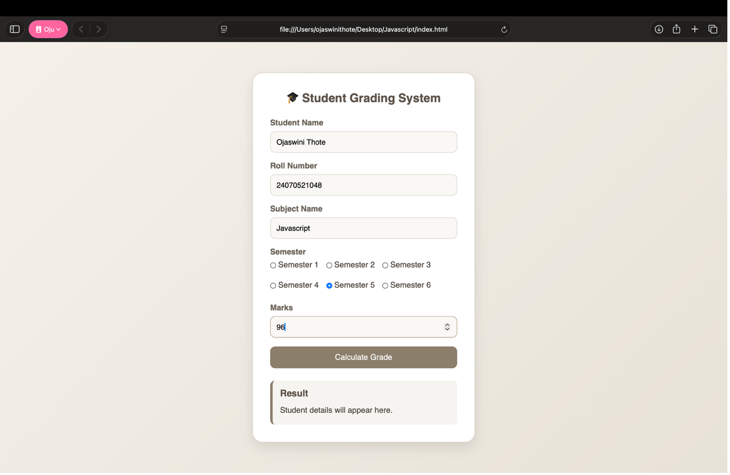
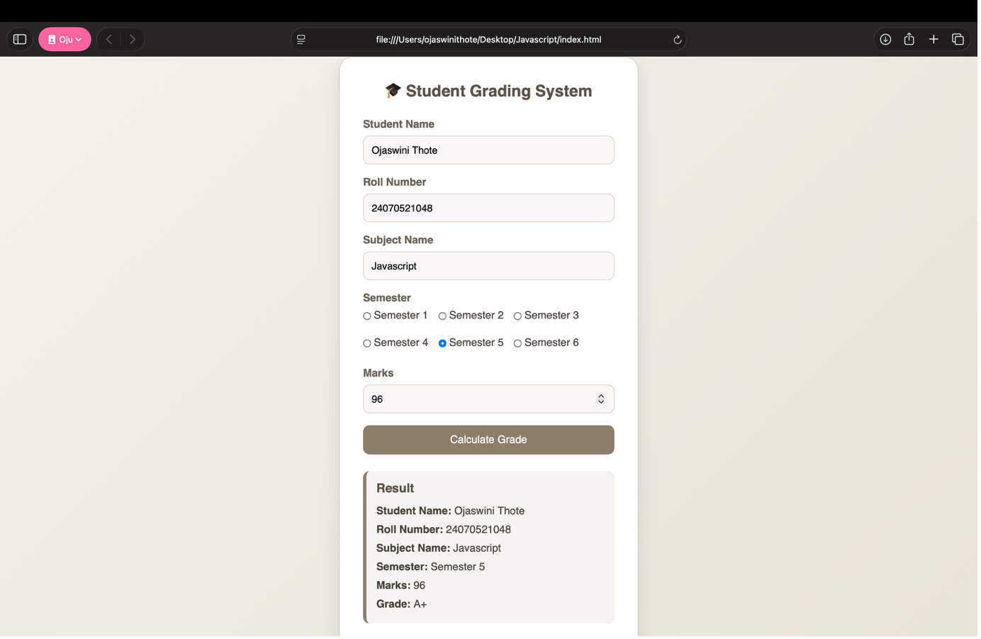
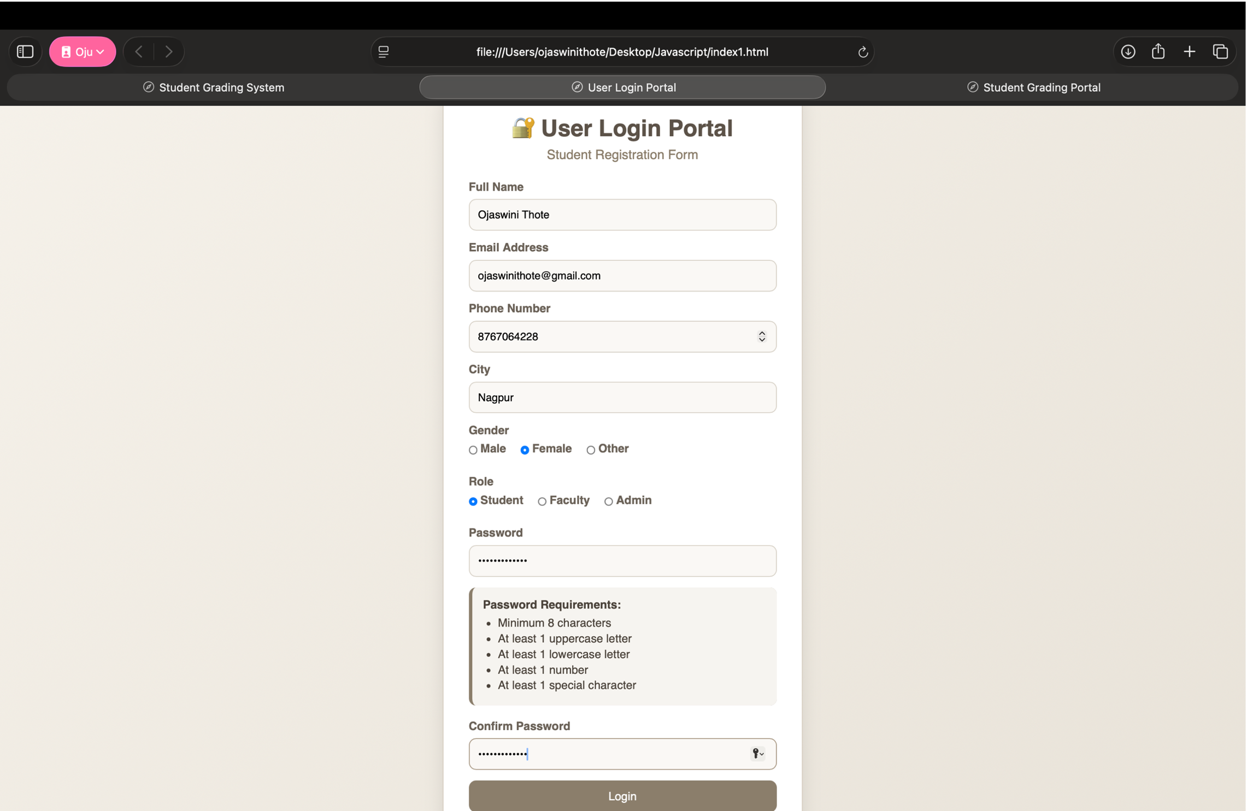

Case Study Title
Student Grading System and Password Validation using JavaScript Control Structures and Form Validation

Case Study Program Code
The practical demonstrates various JavaScript control structures and form validation techniques.
Concept | Usage
**if Statement** | Basic input validation
**if-else** | Pass/Fail determination
**if-else-if Ladder** | Grade calculation based on marks
**Nested Conditions** | Password validation and grading logic
**Logical Operators** | Password and form validation
**DOM Manipulation** | Displaying dynamic results
**JavaScript Functions** | Grade calculation and validation logic
---

Output Summary

Task 1
- Student information is accepted.
- Grade is calculated automatically.
- Pass/Fail result is displayed.

Task 2
- Registration form validates all inputs.
- Password requirements are checked.
- Login status is displayed after successful validation.

Task 3
- Complete academic information is accepted.
- Student result is generated dynamically.
- Print option generates a printable result.

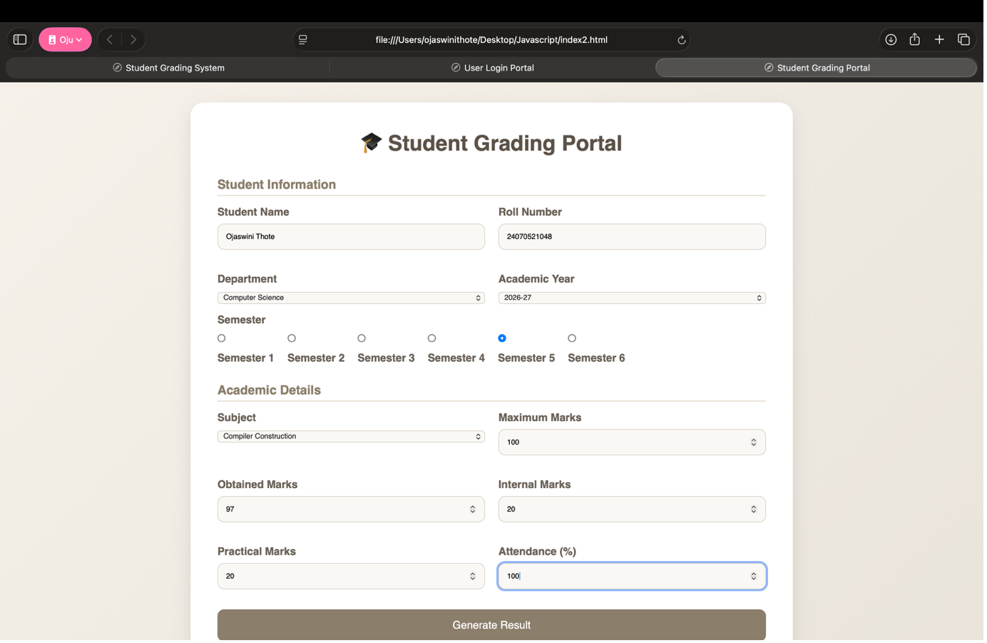
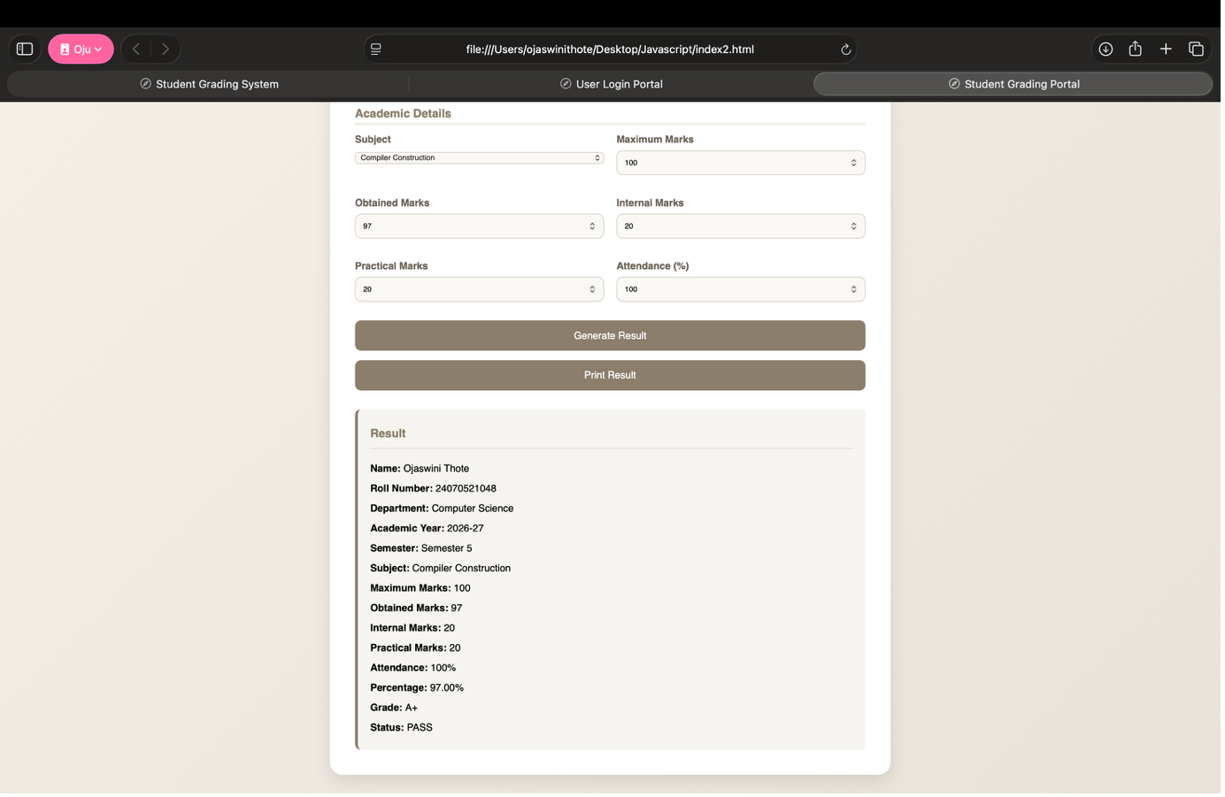

Result / Conclusion
The experiment was completed successfully. JavaScript control structures including if, if-else, if-else-if, nested conditions, and logical operators were implemented effectively. Form validation techniques were applied to validate user inputs, calculate student grades, determine pass/fail status, and verify password strength. The practical demonstrates how JavaScript can be used to build interactive, user-friendly, and responsive web applications for academic grading and secure user registration.

